|  |  |
| --- | --- |
|  | **2013 OMLTA/AOPLV FALL CONFERENCE**  **Radisson Hotel and Conference Centre**  **November 1st and 2nd, 2013**  **APPLICATION and EXHIBIT CONTRACT** |

**Unis en langues / United in languages**

**HST #R104001029**

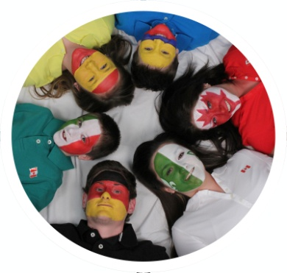

Please type in information, save file under Exhibitor Name and return electronically to omlta@omlta.org.

|  |  |  |  |
| --- | --- | --- | --- |
| Company Name: |  | | |
| Contact Person: |  | | |
| Mailing Address: |  | | | |
| City/Province: |  | Postal Code |  | |
| Telephone: |  | Fax: |  | |
| Email: |  | | | |
| Website: | Click here to enter website address as you would like to have displayed in program | | | |

**EXHIBIT HOURS:**

**SET-UP TIME:** Friday, November 1st - 6:00 p.m. – 8:00 p.m. **OR**

Saturday, November 2nd - 6:30 a.m.

**EXHIBIT HOURS:** Saturday, November 2nd – 7:30 a.m. - 3:30 p.m.

**DISMANTLE TIME:** Saturday, November 2nd - 3:30 p.m.

Electronic submission of Application forms is preferred and may be emailed to [omlta@omlta.org](mailto:omlta@omlta.org). If mail or courier, please send typed completed application form with payment (if paying by cheque **must** be current date payable to the OMLTA/AOPLV, post-dated payments not accepted). Payment **must be received** **within 7 days** to secure your spot. Payments may also be made via credit card over the phone. The **deadline** for applications is Monday August 13, 2013:

OMLTA Administrative Assistant

P.O. Box 10055, Westway Centre Post Office

1735 Kipling Avenue, Etobicoke, ON, M9R 4E2

Tel: 519-763-2099

Email: [omlta@omlta.org](mailto:omlta@omlta.org), Website: [www.omlta.org](http://www.omlta.org)

Please retain a copy of this form for future reference. A receipt and confirmation will be sent to you as soon as your application is processed.

1. **PLEASE RESERVE:**

|  |  |  |
| --- | --- | --- |
| **Qty** | **Items** | **Cost** |
| 1 | 8 ft table at $65.00 + HST $8.45 = $73.45 per table | $73.45 |
|  | Meals @ $50.00 per person | $ |
|  | **Total fees submitted** | **$** |

**B. NAME OF COMPANY REPRESENTATIVES ON SITE**

Please list who will be in attendance. Name tags will be required for admission to the exhibit area. Participating Exhibitors will be required to provide their own company identification at all times during the conference hours. The person listed as the **CONTACT PERSON** on the Exhibit Application form will be in attendance:

**Yes:**  **No:**

|  |  |  |  |
| --- | --- | --- | --- |
| 1. | Click here to enter name of Rep | 2. | Click here to enter name of Rep |

**C.** We will be providing a door prize for the draw which will take place during the lunch break on Saturday, November 2nd, 2013.

**Yes:**  **No:**

|  |  |
| --- | --- |
| Our prize will be: | Click here to enter name of item being donated |

**D. PLEASE INDICATE WHEN YOU WILL BE SETTING UP YOUR DISPLAY AREA:**

Friday November 1: 6:00 p.m. – 8:00 p.m.

Saturday November 2: 6:30 a.m.

**PAYMENT INFORMATION: Visa or Mastercard Accepted (OMLTA HST #R104001029)**

|  |  |
| --- | --- |
| Charge My Credit card: | Visa  M/C |
| Amount to be Charged | **$** |
| Account Number: |  |
| Expiration Date: mm/yyyy |  |
| Cardholders Name: |  |
| Authorized Signature of Cardholder: |  |

**SIGNATURE AND AGREEMENT:**

The Exhibitor agrees to abide by all exhibit terms, conditions and regulations set forth in this contract.

___________________________________________ _______________________

Authorized Signature Date

___________________________________________

Print Name and Title